|  |  |
| --- | --- |
|  |  |
| C:\Users\ensrcb\AppData\Local\Microsoft\Windows\Temporary Internet Files\Content.Word\rgu logo colour.png |
|  | |

|  |  |
| --- | --- |
|  |  |

|  |  |
| --- | --- |
| **COURSEWORK**  **DUE DATE** | 14/12/2019 |
| **MATRIC No** | **1909247** |
| **SURNAME** | **Chatzileftheris** |
| **FIRST NAME(S)** | **Stefanos** |
| **COURSE TITLE** | **IT for Oil and Gas Industry** |
| **MODULE NUMBER**  **& TITLE** | **CMM007 – Intranet System Development Part2** |
| **LECTURER ISSUING COURSEWORK** | **Stewart Massie** |

**RGU Research Paper Project (CMM007-PART 2)**

**1)A Brief Description for the Project**

This project designed to implement a web application that will help group project to upload, identification, review, monitoring and following of research papers between the group members. The research activities will be report writing, review and other similar tasks can be to monitor and track the editorial progress of several papers within a limited time. Furthermore, this project will give the opportunity for the user to create platform that will support group project teams.

In this system they will be three types of users: Administrator, Student Team Leader and Students. All users will have access to the register system i.e. members will be required to log in. The administrator has the highest role to manage the tools on the platform, and he will only has the access to create users, setup project groups, allocate team leader role and assign members to the project. The team leader is responsible for delivering papers to members for review and. Students will be able to upload research papers, this will be submitted to the Student team leader, who will allocate it to any members for review.

* 1. **Software-architecture**

I am using the first-tier architecture for my project because of the situation. I only use a localhost from my apartment xampp to do all the necessary changes in php for my project. My project follows the three layers down below which is presentation, business and data layer, which i am going to explain down below.

**Presentation Layer:** Using this level, we can access the websites. The primary function of this layer is to communicate with the application layer. This level transmits the information supplied by the user in terms of keyboard events, mouse-click the application level. In a simple word, it is to see the implementation.

**Application/Business Layer:** It is also known as the Business Logic Layer, which is also known as Layer Logic. According to the example of the login page with the message, after the user clicks the Connect button, the application layer interacts with the level of the database and sends the required information to the presentation level. It checks the functionality of an application by making detailed processing. This layer acts as an intermediary between the level of presentation and database.

**Data Layer:** The data stored at this level. The level of application communicates with the database level to recover the data. It contains methods that link the database and perform the required actions, such as: insert, update, delete, etc. Which in this situation I ma using xampp (localhost).

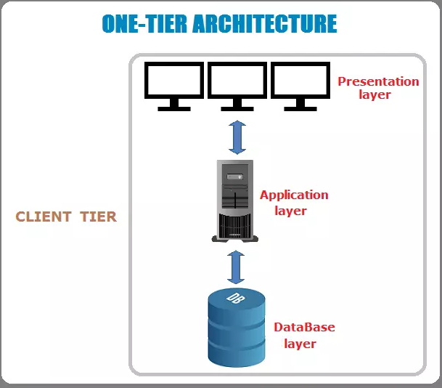

Figure 1) First Tier Architecture Diagram

The data stored in the local system or a shared drive.

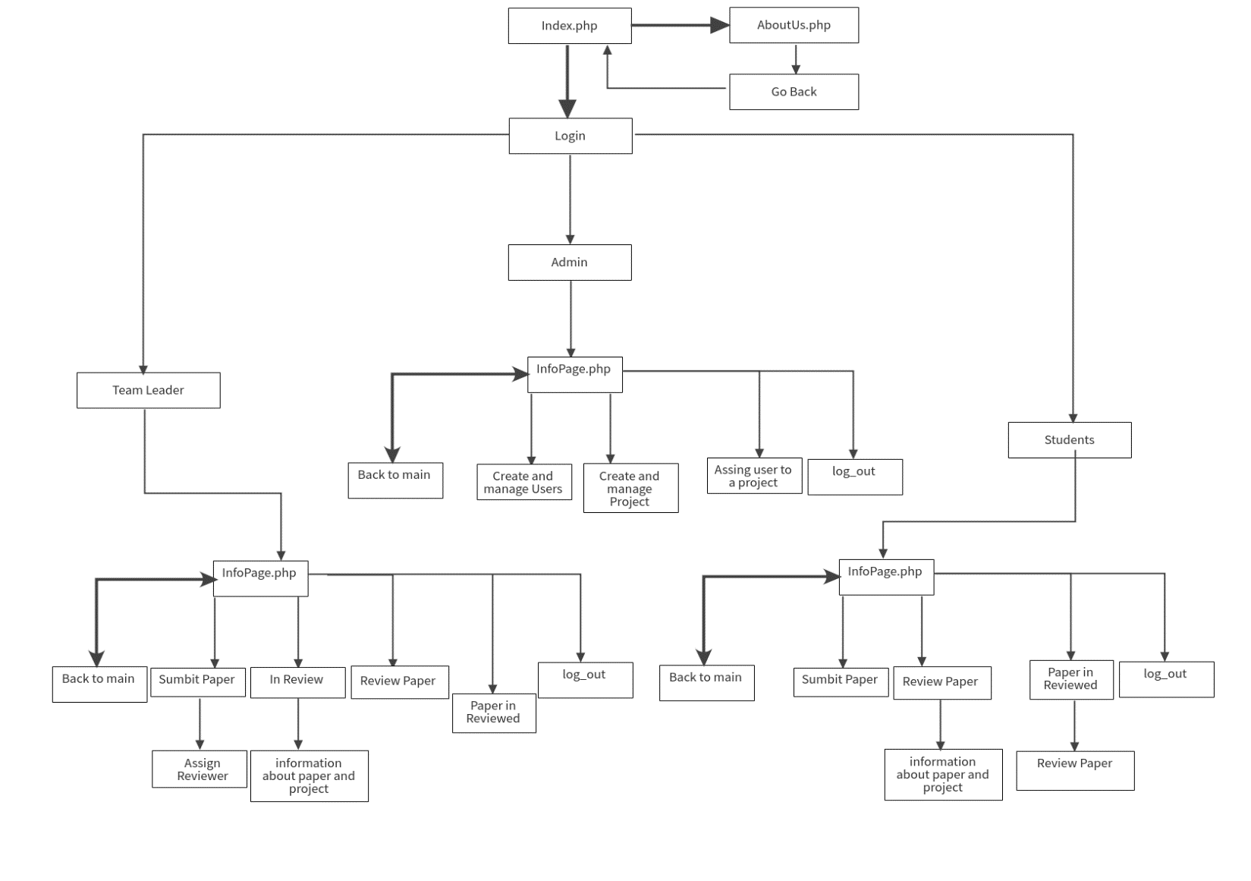

**Figure 2) Sitemap of the project**

* 1. **Libraries**

I used Bootstrap and Fonts-Awesome as existing code libraries.

**Bootstrap:** is a framework to help you design websites faster and easier. It includes HTML and CSS based design templates for typography, forms, buttons, tables, navigation, modals, image carousels, etc. It also gives you support for JavaScript plugins.

**Font Awesome:** is a web font containing all the icons from social media. To do so, you'll need to use the following CSS on the desired element, and then substitute in the content value for the relevant icon. Font Awesome provides thousands of icons. The “Library” is the way you can subset or reduce file sizes and reference icons easily.

* 1. **Diagram of the database design**

A system for user to input data that is stored and then recalled from a database: The system will support data storage for example documents or reviewing papers and retrieval using HTML, PHP in the application and MySQL(phpMyAdmin) for the database server.

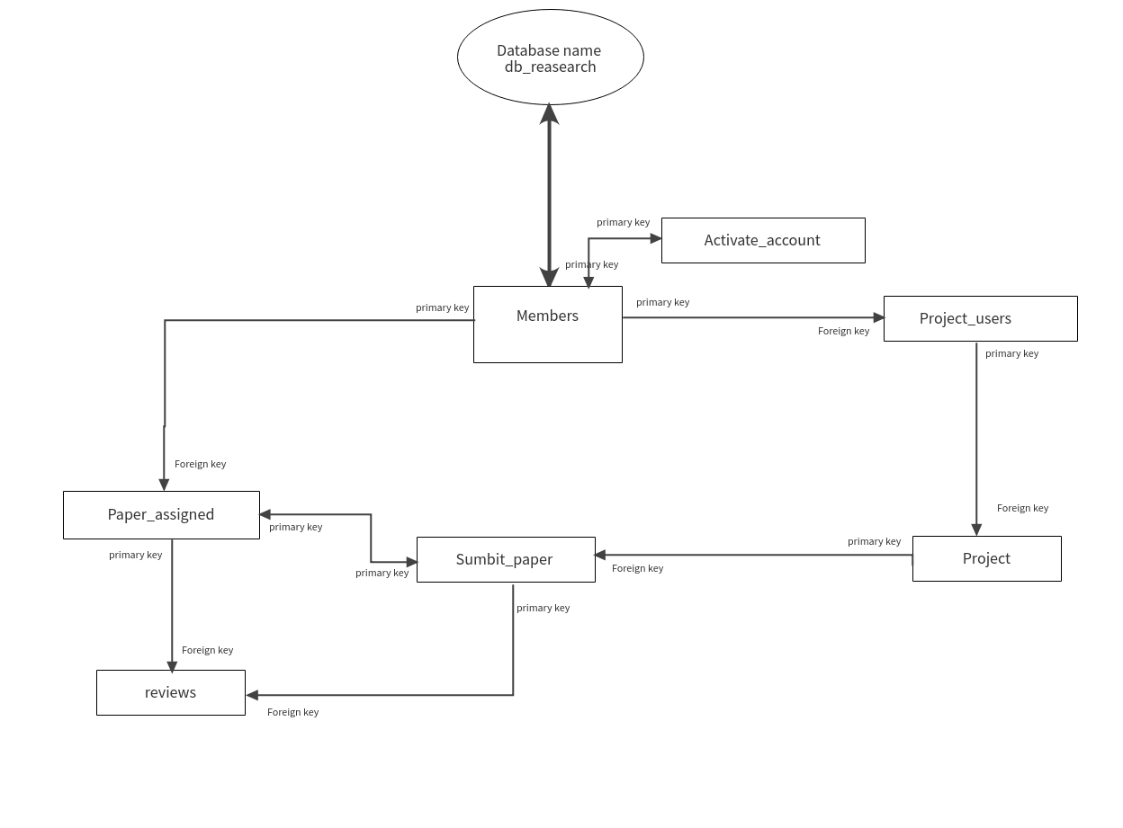

**Figure 2) Database Design**

**Explanation about the database:** I am using Xampp as localhost. The database name in phpMyAdmin is dB research. Which included table Members with all the users. Admin can create a new user and activate the account from (activate_account).In addition he can create a project which is the table(Project) and Assign a user to a project table(project_users).The users will be able to submit a paper( table Sumbit_paper) and reviews it as users Table(reviews).The team leader will be able to assign a student to a paper table(Paper_assigned).

**2) Brief statement of compliance stating**

***2.1)*** **Requirements have been implemented**

The system shall be structured into front-end and back-end. The front-end is the presentation layer which the user sees and interacts with, while the backend is the logic and data layer which performs the behind the scene operation and data storage. My project has been implemented a lot of requirements, which I am going to explain briefly. Every user of the system must be required to login to use the web app. The system must be able to store all the users, projects, uploaded research papers, reviewed papers and comments.

As an Administrator you can login to the system to gain access. He can create a project and add users to it. Moreover, he can be able to sets up a project and allocate students and team leaders to the project and give them roles (team leader or student). Furthermore, the administrator can manage all the projects and the users of the system.

As a Team leader you can allocate papers to students for review. Also, team leader should be able to upload research paper and assign paper to students for review. The system should save all the research papers that the user can to review at any given period as a team leader.

As a Student you can should enter the system through a personalized link and can then be able to upload research papers, see any papers that have been allocated to them to review and upload their reviews, be able to view all papers and reviews. In addition will be able to download papers, upload reviewed research papers and add comments. Other members of the project group should be able to see the reviewed paper and comment on it.

***2.2)*** ***Requirements have not been implemented***

In the project you are not able to change the password as a user and team leader and you are not able to change your photo profile. In addition, you are not able to visit profiles. Moreover, I didn’t implement any alert for any action which is a must implement for the future improvements. As users in the login system forum need to have a button if someone forgot the password to login. The application shall be able to function with other hardware devices. All the users should be authorized to use the system and try to avoid cyber and physical attacks. For the database: A backup must be saved to avoid any disaster and be recovery in cases of disaster. Moreover, the cookies: The application could have a cookie so the users should not type every time the password to get to the app.

As an Administrator you can’t not edit the Project but only you can create them. Furthermore, as Admin you cannot change information through the system but only from the database (localhost xampp).

As a User and team leader you are not able to edit your profile and change your password inside the system. A team leader has to view the projects and the users which is not implement into my project. In addition, as a team leader can remove from a project a member if it’s necessary or edit the assigned.

**3)Test plan and test results completed for the full application**

The test plan is describing the scope involved in condition/action being checked, functionality of the resources and expected result.

**Test Plan**

***3.1)*** First test will be the index.php. Testing the about us page and the login, logout system for all the users and the home footer.

|  |  |  |  |
| --- | --- | --- | --- |
| **The purpose of the test** | **Expected results** | **The actual results** | **Action Taken: Pass/fail** |
| **Click on the About us button** | Check when the button on the top right at the corner About us | About us button correctly displayed | Pass |
| **Aboutus.php go back to the index.php** | Check if the button on the top right goes back to the index page | When the users click the button go back should go back to the index.php | Pass |
| **Login on header correctly functioning** | Check when initiating Index.php that the top right of the header displays login buttons login | Login buttons correctly displayed | Pass |
| **Login implimenation** | Click on ‘login’ submit button. | User is pressing login button.  After correctly signing in, check that user goes to info page.  The submit buttons ‘login’ are no longer displayer. That ‘welcome “username” ‘is displayed and the photo of the user | Pass |
| **Logout** | There is a submit button ‘logout’ next to the photo | The user can successfully log out from the system and go back to the main page(index.php) | Pass |
| **Main Footer Click all the button** | Check if all the button in the main footer works correctly for the social media, policy, data protection and email | When you click the social media button you are going directly to the social media of Robert Gordon University. In addition when you click policy and protection is connect you with the policy and protection of Robert Gordon University, same for the email, it connect you with email address via outlook. | Pass |
|  |  |  |  |

***3.2)*** Second Test is going to be when the user is the Admin.

|  |  |  |  |
| --- | --- | --- | --- |
| **The purpose of the test** | **Expected results** | **The actual results** | **Action taken: Pass/fail** |
| **Click and check all the button in navbar as an Admin** | Check if the button in navbar of admin works properly | You can click all the button without any problem, and you can go to a different php files | Pass |
| **InfoPage.php** | Check if the tab bar work properly and if you can go via links to the other webpages | Its s saw you all the submission, reviews and achieves correctly without any problem | Pass |
| **Create and Manage User** | Check if as Admin I can create and manage users | some small issues with the localhost xampp. It’s saw an error at the top from the database, but the user can be created with not a problem and also you can delete him without any problem. | Pass |
| **Create and Manage Project** | Check if all the functionality works if you want to create and manage a project as an Admin | All the functionalities work without a problem. The admin can create a project without a problem all the buttons (create and delete project) works correctly. | Pass |
| **Assign User to Project** | Check if as an Admin can Assign a team leader to a project. | The only small issue is when the admin assigns a user to a project will give him also the students list which is not correct if admin don’t know who the team leader is. On the other hand, the admin can assign a user without any problem into to a project | Pass |
| **Back to Main** | Check if the button back to main goes back to the main page info page | If you click the button back to main, goes back to the main page of the project without any delay and problem. | Pass |
| **The Footer when as an Admin** | Check if the footer works properly | The footer works properly, the admin can click without any problem all the privacy and cookies statement, and send an email to the technical department | Pass |
|  |  |  |  |

***3.3)*** Third Test is going to be when the user is the Team Leader.

|  |  |  |  |
| --- | --- | --- | --- |
| **The purpose of the test** | **Expected results** | **The actual results** | **Action taken: Pass/fail** |
| **Click and check all the button in navbar as a Team Leader** | Check if the button in navbar of team leader works properly | You can click all the button without any problem, and you can go to a different interfaces without any lag | Pass |
| **InfoPage.php** | Check if the tab bar work properly and if you can go via links to the other webpages | Its s saw you all the submission, reviews and achieves correctly without any problem | Pass |
| **Submit Paper** | Check the team leader if can upload a file and submit that file as a paper for future review | As a team leader can upload files like DOC, DOCX, TXT and you are able to see an error message if you don’t know upload the correct type of file. In addition, if you don’t know fill all the empty task that are require you are not able to submit the file | Pass |
| **Assign Reviewer** | Check if the team leader can assign reviewer into the projects | An issue appears when you assign the student into the projects makes visible the admin as an option to assign into the project and you are not able to remove some from the project if you by mistake add it on the project. On the other hand, the form works properly, and you can assign any student to review a paper. |  |
| **In Review** | Check if the team leader can see all the papers in review | The team leader can see all the details for the project and the users who s submits into the project without any issue | Pass |
| **Info for papers and project** | Check if you can see all the project and the papers as a team leader | When you click on a specific file or project it’s saw you all the information from the paper and all the information for all the project | Pass |
| **Review Paper** | Check the team leader if can see the paper awaiting to review | The Team leader is able to see all the task that is assign on and he can review them without any problem. | Pass |
| **Papers Reviewed** | Check as a team leader if he can see in paper reviewed, he s comments from a previous assigned | No issue it seems to apeira into this page. The team leader can see all his rewired papers, it’s works properly. Also you can click back to review paper if you want to add some extra comments | Pass |
| **Back to Main** | Check if the button back to main goes back to the main page info page | If you click the button back to main, goes back to the main page of the project without any delay and problem. | Pass |
|  |  |  |  |
| **The Footer when as a Team Leader** | Check if the footer works properly | The footer works properly, the team leader can click without any problem all the privacy and cookies statement, and send an email to the technical department | Pass |

***3.4)*** LastTest is going to be when the user is the Students.

|  |  |  |  |
| --- | --- | --- | --- |
| **The purpose of the test** | **Expected results** | **The actual results** | **Action taken: Pass/fail** |
| **Click and check all the button in navbar as a Team Leader** | Check if the button in navbar of team leader works properly | You can click all the button without any problem, and you can go to a different interface without any lag | Pass |
| **InfoPage.php** | Check if the tab bar work properly and if you can go via links to the other webpages | Its s saw you all the submission, reviews and achieves correctly without any problem. As student you are not able to see all the reviews but only yours | Pass |
| **Sumbit Paper** | Check the students if can upload a file and submit that file as a paper for future review | As a student can upload files like DOC, DOCX, TXT and you are able to see an error message if you don’t know upload the correct type of file. In addition, if you don’t know fill all the empty task that are require you are not able to submit the file | Pass |
| **Review Paper** | Check the student if can see the paper awaiting to review | The student can see all the task that is assign on and he can review them without any problem. | Pass |
| **Papers Reviewed** | Check as a student if he can see in paper reviewed, he s comments from a previous assigned | No issue it seems to apeira into this page. The team leader can see all his rewired papers, it’s works properly. Also, you can click back to review paper if you want to add some extra comments. | Pass |
| **Back to Main** | Check if the button back to main goes back to the main page info page | If you click the button back to main, goes back to the main page of the project without any delay and problem. | Pass |
| **The Footer when as a Team Leader** | Check if the footer works properly | The footer works properly, the student can click without any problem all the privacy and cookies statement, and send an email to the technical department | Pass |
|  |  |  |  |

**4)** **Usernames and passwords needed to test the application**

|  |  |  |
| --- | --- | --- |
| **Username(email)** | **Password** | **Role** |
| admin@mail.com | admin | Admin |
| teamleader@mail.com | leader | Team Leader |
| student@mail.com | student | Student |

***4.1)*** **The link to your GitHub Repository :**

All codes will be available on GitHub at <https://github.com/stefanos03/RGU-RESEARCH-PAPER-PROJECT>